**CONDITIONAL STATEMENT (IF)**

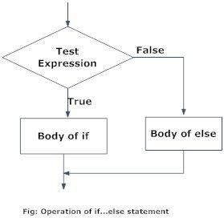

|  |  |  |
| --- | --- | --- |
| if Statement | The Python **if statement** is used to determine the execution of code based on the evaluation of a Boolean expression.  If the if statement expression evaluates to True, then the indented code following the statement is executed. | **test_value = 100 if test_value > 1:**     print("This code is executed!") **if test_value > 1000:** **print("This code is NOT executed!") print("Program continues at this point.")** |
| elif Statement | The Python **elif statement** allows for continued checks to be performed after an initial if statement. An elif statement differs from the else statement because another expression is provided to be checked, just as with the initial if statement. | **pet_type = "fish" if pet_type == "dog":    print("You have a dog.") elif pet_type == "cat":    print("You have a cat.") elif pet_type == "fish":**    **print("You have a fish") else:    print("Not sure!")** |
| else Statement | The Python **else statement** provides alternate code to execute if the expression in an if statement evaluates to False. | test_value = 50 if test_value < 1:    print("Value is < 1") else:    print("Value is >= 1") test_string = "VALID" if test_string == "NOT_VALID":   print("String equals NOT_VALID") else:   print("String equals something else!") |